

Politecnico di Milano

A.A. 2016-2017

Software Engineering 2: PowerEnJoy

**D**esign **D**ocument

*Lorenzo Frigerio (mat. 879203)*

*Martina Perfetto (mat. 808869)*

*Ivan Vigorito (mat. 879204)*

11th December 2016

*Version 1.0*

Contents

1. Introduction 3

1.1. Purpose 3

1.2. Scope 3

1.3. Glossary 3

1.3.1. Acronyms 5

1.4. References 5

1.5. Document Structure 6

2. Architectural Design 7

2.1. Overview 7

2.2. High level components and their interaction 8

2.3. Component View 9

2.4. Component Diagram: Web Service 9

2.5. Component Diagram: User Management 9

2.6. Component Interfaces 9

2.7. Deployment View 10

2.8. Runtime View 10

2.9. Selected architectural styles and patterns 10

3. Algorithm Design 11

4. User Interface 11

4.1. Design Overview 11

4.2. User Interface and navigation flow 11

4.3. Further preview of the UI 13

4.4. User Experience 14

4.4.1. Sign Up process 14

4.4.2. Reserve a Car 15

4.4.3. Unlock a car and end rental 16

5. Entities Architecture 17

5.1. E-R Diagram 17

5.2. Relational Model 18

6. Requirements Traceability 18

# Introduction

## 1.1. Purpose

This document describes the specific architecture and design of “PowerEnJoy”.

The focus will be on structural and design styles choices, expanding the thread already analysed in RASD document.

The design document in effect, starting from the requirements given in the RASD build a feasible architecture for the application.

## 1.2. Scope

The document will present different level views in order to describe clearly the architecture of the application. In particular, will be presented the component view, both high and low level, the deployment view, the runtime view and a further description of user interface, analysed in its runtime flow.

## 1.3. Glossary

User / registered user: he/she is the client of the service; he/she is able to rent a car in order to travel around the city. He is associated with:

-Name

-Surname

-Other personal information

-Method of payment

-Number of driving licence and expiration date

-Password

Employee/operator: is the one that help users in case of emergency and has the responsibility of managing cars in case of malfunction. Users can call them by using the telephone exchange of the application.

Method of payment: is inserted by the user during the registration phase but can be updated over the time. Only one method is active at once and payment are concluded using services offered by the different companies holding the credit card. An invoice containing all the charges collected is generated monthly.

Car: sometimes referred as vehicle is the means of transport rented by users. It contains a set of sensors that analyse the number of passengers presents on the car, control the charge of the battery and detect when a door is closed. Moreover, it includes a module that transmit this information to the system using the Internet.

Available car: car that is not in use at the moment by any user, has at least 20% of charge and is not reserved by anyone.

Reservation: made by a user that wants to use a car. Has a duration of one hour maximum and is associated with a unique car. Once the user asks to unlock the car the car becomes associated to the user until he decides to end the ride.

Charge: amount of money that users have to pay due to the use of the service. It is immediately calculated by the system after a ride but money is transferred only at the end of the month.

Penalty: fee derived from a bad behaving of the user such as a damage on the car or a fine for exceeding speed limits. The fee will be notified to the user and included in the monthly invoice.

GPS navigation device: system that equip each car and that is able to calculate the exact position of the car and display to the user the route to follow. Its display is also used to show the current fee of the ride and the status of the battery.

Start/stop button: device present in all the electric cars that allow the engine to ignite when the car is unlocked. It also allows the engine to stop when the user wants to get off the car.

Special Safe Area: special parking areas that contain plugs that allow cars to be recharged. They are provided with sensors that detect the number of spots that are currently used and communicate the number to the system. They are also called power grid stations.

Safe Area: Space included in boundaries that determine where users can park a car. It covers entire metropolitan cities in order to facilitate users to find a park and they may also contain power grid stations. Users cannot terminate a ride while outside from a safe area.

Ride/Rental: it last from when the user picks up the car until when the system stops charging the user. It includes a possible set of temporary stops and the total path travelled by the user.

Distance: It is the lengthiness of road which is covered by the user with the rented car.

Park: is when a user leaves the car and wants to end the rental. At this point the system stops charging the user.

Stop: is when a user leaves the car but wants to resume the ride in the future. The car will be locked by the system that, however, will continue to charge the user for the ride.

### Acronyms

SPA: Special Safe Areas

SA: Safe Areas

## 1.4. References

* Requirements and Specification Document, RASD
* IEEE Standards for Information Technology Systems, Design Document

## 1.5. Document Structure

The Design Analysis is based on a Top-Down approach, therefore the Document structure will follow the same path. It will start from the high-level architecture, presenting the main components with their operations and mutual relations (2.2). Then it slides down to a lower level in which the high-level components are decomposed and analysed in detail (2.3).

After that in 2.4 paragraph will be presented the Deployment view of the system that show the execution architecture of the system representing the deployed software and hardware artefacts.

Runtime view presented in 2.5 paragraph will show the behaviour of the system during some typical situation. That will permit to understand in an easier way how the execution flow works.

The lowest level of analysis is reached in paragraphs 2.6 and 2.7 where are described the inner composition of the Interfaces and the Architectural choices which have been made to design the system.

Lastly, will be presented some of the main algorithms that are the fulcrum of the entire system. They will be described through pseudo-code.

Chapter 4 will take the User Interface already presented in RASD and give further information about the design choices. It will also describe some UI flows clearing up the navigation through different web pages or mobile screens. The paragraph about User Experience will get over the mere “Look Requirements” presented in RASD and it will deeply analyse the structure of the Web Application.

The last chapter presents the architectural choices about the Database structure. In particular will be presented the E-R diagram and the correspondent relational model.

# Architectural Design

## 2.1. Overview

The architectural design of the application is based on three different tiers, which are the CLIENT-tier, the BUSINESS LOGIC-tier and the ENTITY-tier:

* CLIENT-tier: It is represented by the web application and the mobile app used by the users as part of a thin tier. In addition, there is also the employee application that allows operators to manage the maintenance and the problems related to the cars. Lastly there is the application running on the car. This app allows the management of the display present on the car and the sensors used to verify the presence of discount and communicate them to the system.
* BUSINESS LOGIC-tier: It is the core of the application and plays as a mediator between the requests of users and employees and the cars. Moreover, it manages the reservation process and the safe areas.
* ENTITY-tier: It contains the manager of the data. It is responsible of database modification such as the insertion or the retrieving of any kind of data.

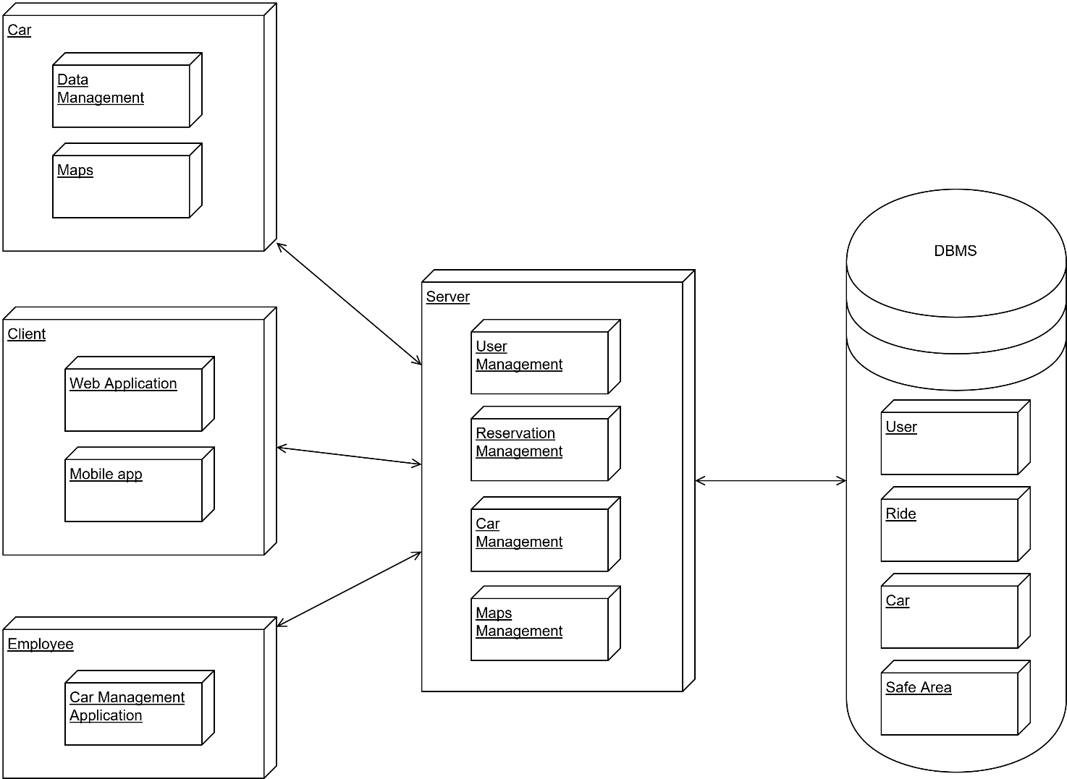

## 2.2. High level components and their interaction

The following diagram illustrates a high level architecture of the system. It shows how communication between the different clients and the central system are managed.

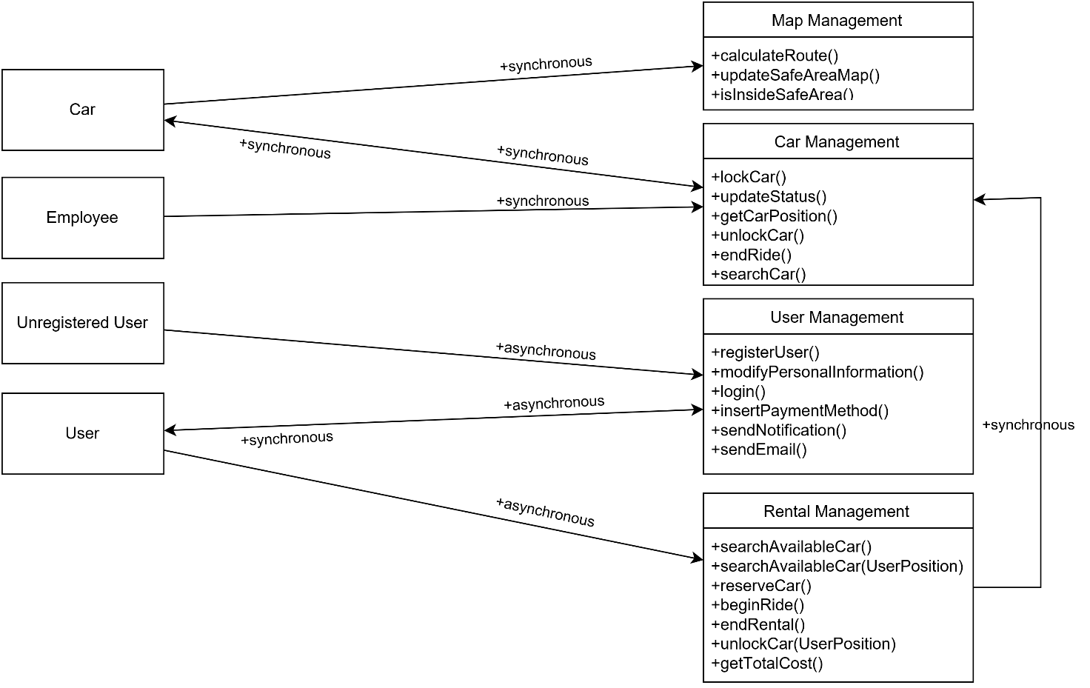

CAR-Map Management: this communication allows the cars to retrieve the information about maps; Indeed, the car may need the path to follow in order to apply the “Money Saving Option”. Cars are provided with the latest version of the position of safe and special safe areas that is updated regularly.

CAR-Car Management: this communication grants the possibility for cars to communicate some information to the system. In fact, cars tell the system when all the users are exited from the car and asks to the system the confirmation to lock.

Car Management-CAR: the system has the chance to ask to the car if a discount can be applied and in order to get the position of the car.

Employee-Car Management: the employee has the opportunity to manage the maintenance and all the problem related to the cars. Through a web application they can ask to change the status of a car if under maintenance or check their positions.

User-User management: users can ask to the user manager to perform a login or to update their personal information. Moreover, they can insert or update the method of payment in case it is expired.

User-Reservation management: after the login the user can ask for a reservation by selecting on the available cars proposed by the system. In addition this block performs the operations related to the rides such as the begin of a ride (unlockCar()) e its end (endRental()).

## 2.3. Component View

The cdsv

## C:\Users\defi9\Downloads\Component Diagram 2.1.png2.4. Component Diagram: Web Service

## 2.5. Component Diagram: User Management

## 2.6. Component Interfaces

In a system each component interacts with other elements inside the system. The communication between components is managed using interfaces. Every interface has a set of methods, which could be called by another component in order to perform specific actions. The components can avoid to know how the operations are implemented in each element.

Here are presented a description of each interface presented in the component view, in order to explain the interaction between components.

* **DB Service**
  + - +insertUser(User usr : void)
    - +insertReservation(Reservation reserve : void)
    - +insertEmployee(Employee empl : void)
    - +insertRide(Ride rid:void)
    - +insertCar(Car car:void)
    - +modifyEmployee(Employee empl : void)
    - +modifyUser(User usr : void)
    - +updateStatus(Status stat, Car car:void)

The set of methods defined above are used so as to insert values and query inside the DBMS. With these methods it is possible to add or modify query inside databases. They take the entities classes, with every detail related, that will be decomposed in basic type pieces of information and inserted in the database.

* **Map Management**
  + - +calculateRoute(String departure, String destination)
    - +isInsideSafeArea(Car car, GPSData local_car)

This set of methods concerning all the things which the service needs concerning the problems related to the map.

* **Reservation**
  + - +reserverCar(String username, Car car, Date reservation_date, Time reservation_time : Bool confirmation)
    - +searchAvailableCar(GPSData local)
    - +searchAvailableCar(String departure_address)
    - +unlockCar(Car car, String username, GPSData local_user)

This interface allows users to rent a car from his web-application. The interface for each method need some information passed as parameters such as, the client username, the car selected or GPSData. The “unlockCar” method is different from the method inside the car management interface, that because first of all the user ask to the “Reservation” component to unlock the car, which will analyse the position between the user and the car. After that the “Reservation” component will ask to the “Car management” to unlock the specific car.

* **Ride**
  + - +beginRide(Car car, Reservation reserv)
    - +endRental(Car car)

The ride interface provides the methods to manage the ride of a reservation. The system with these methods has all the information in order to track the car and define the final invoice of rental.

* **Status**
  + - +lockCar(Car car)
    - +unlockCar(Car car)
    - +updateStatus(Employee employ, Car car, Status stat)

This set of methods is the interface of status component. It provides all the methods in order to change and set the car status.

* **User Manager notification**
  + - +sendEmail(String email, String event_type, String user_destination, String password)
    - +sendNotification(String username, String event_type, String event_id)

This set of methods is created in order to send notifications and emails from the server to the users. The first method is used also as requested inside requirements in which it is asked to send an email with his password as soon as the user fulfilled the registration forms.

## 2.7. Deployment View

The cdsv

## 2.8. Runtime View

The sequence diagram reveals the structure of the communication between the main objects of our application during a ride. Firstly, a user, through the mobile app asks to the system to begin or resume a ride calling the beginRide() method. If the information provided are correct the car is unlocked and the status of the car is updated to “inRide”. Now, the user can freely use the car and exploit the service offered by PowerEnJoy until he decides to have a break. As soon as all the passengers has left the car, this information is notified to the system that lock the car and update its status in “Stopped”. This process goes over until the user asks to end the rental; at this point, the system, after having checked if the position is inside a safe area, asks to the car the information about the ride such as the duration and the possible discounts. The status is updated again in order to set the car available for other users and the final cost of the ride is calculated. Finally, the calculated cost is sent to the car that shows the number over its display.

## 2.9. Selected architectural styles and patterns

# Algorithm Design

4. User Interface

4.1. Design Overview

The main idea during the developing of user’s interface is to create an application (web and mobile) which is easy and immediate fort the user.

As we can see, the user interface is designed to meet these requirements. From the mock-ups presented in RASD, here it is presented the links between the single interfaces, in order to make the procedures intuitive and as easiest as possible.

4.2. User interface and navigation flow

Here it is presented a diagram which depicts how pages are linked among them. In this diagram it is also described: the input forms, different pages and how the navigation through the website is structured.

The diagram is presented as a class diagram, and the symbols have the same meaning as if they were used in that kind of diagram. The tag <<page>> means that the class represent a web page, and <<form>> identifies an input form contained in a specific page.

The home page structure is the same for employee and users. The unregistered users can register themselves through a specific page, reachable from the home page. The registered user can access to the rental service, so every register user is able to reach pages for which he has permissions.

Here are presented only direct flows, associations representing cancellations or links to previous or home pages are omitted in order to simplify the reading of the diagram.

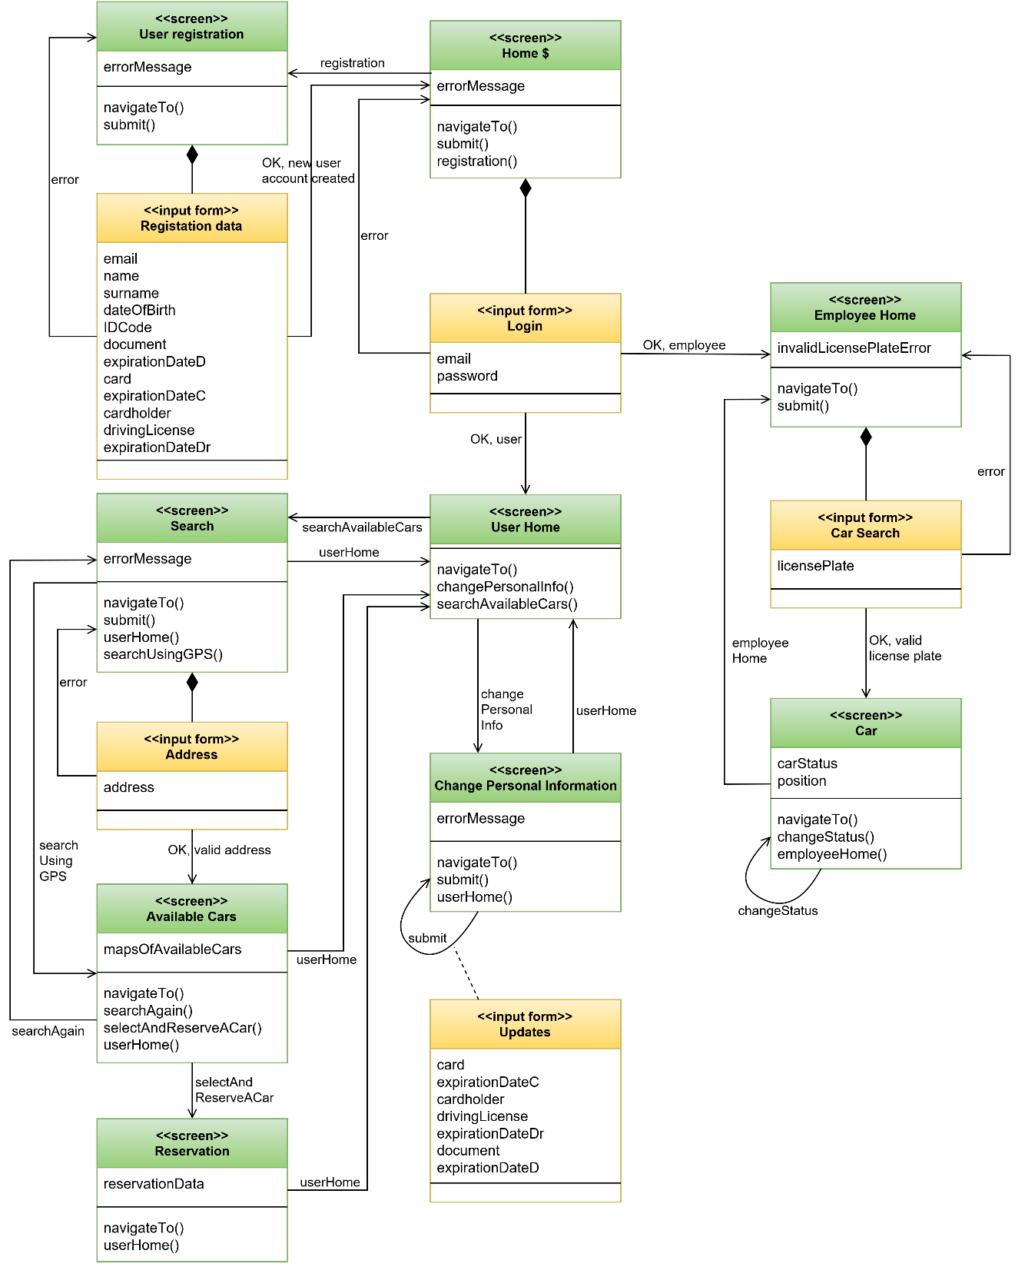

4.3. Further preview of the UI

Here we present other mock-ups, which are not putted inside RASD. These mock-ups are presented with a brief description. They have been created in order to clarify some detailed aspects.

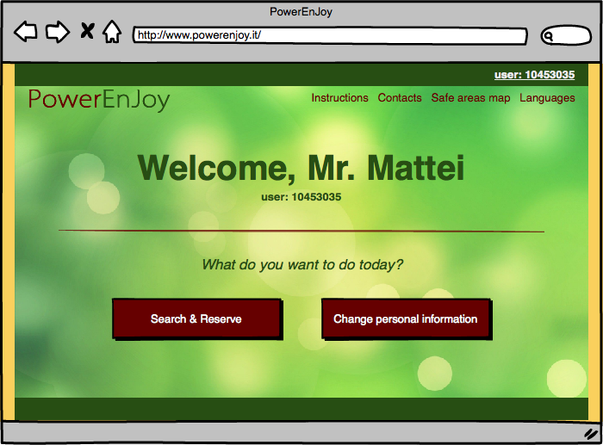***Welcome page registered users;***the register user will see this page after the login.

***Employee panel;*** the employee with this panel is able to change the status of a car in case of issues

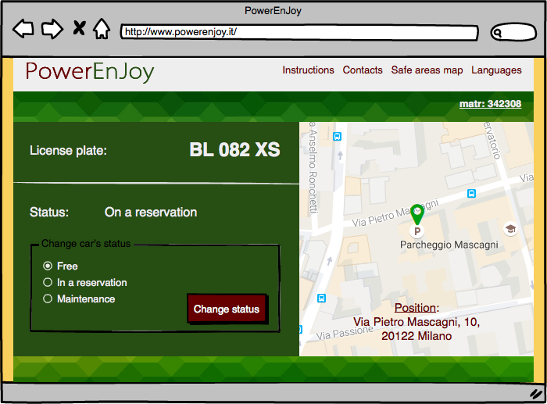

***Welcome page employees*,** employees will see this page after login

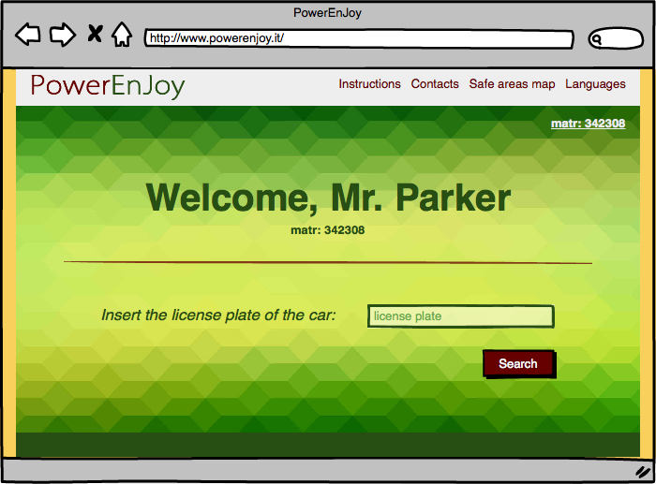

***After Reservation page,*** the user after the reservation will see a brief summary

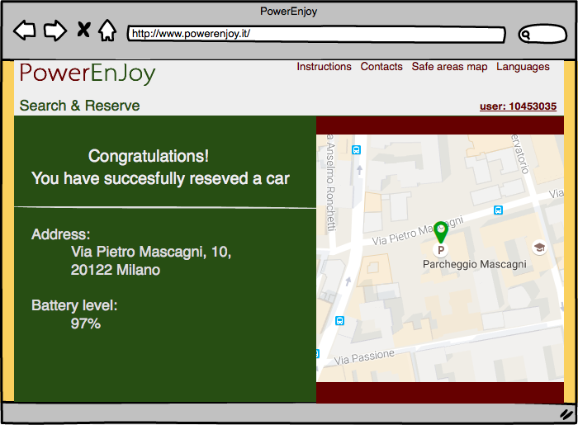

## 4.4. User Experience

In order to make the service as immediate as possible the sequence of actions which need to be performed so as to reserve a car are few and very easy. Inside the home page the Unregister user is able to create a profile in PowerEnJoy.

Every option is fully described in the RASD section related to Use Cases, and the navigation uses only buttons to navigate through the pages, and forms to insert data.

There are shown some page flows based on the mock-ups already presented in RASD, in order to fully describe how pages are linked, and in which way the navigation is structured.

### 4.4.1. Sign Up process

When a new User reaches the page, he can Sign up his profile inside PowerEnJoy. Inside the home page there is a signup button: in the following page he will find the registration form.

The new user needs to register himself in the website in order to use the website features such as make a reservation.

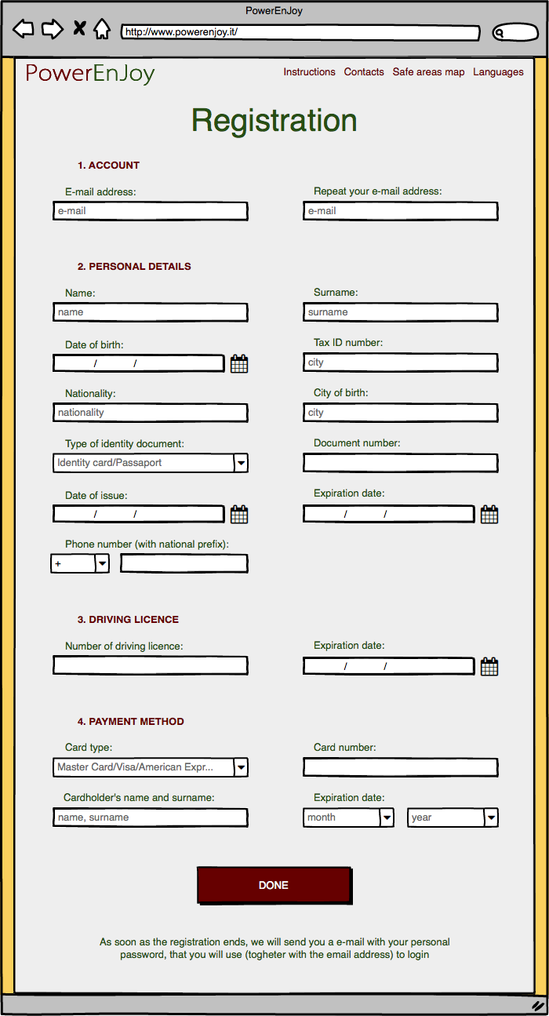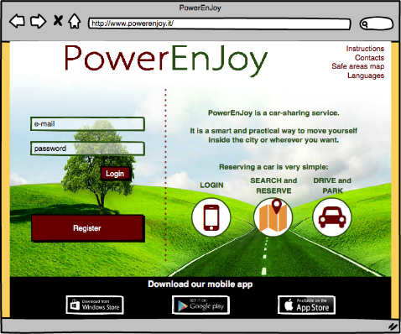

### 4.4.2. Reserve a Car

A registered user can reserve a car from the website. First of all, he needs to be registered so as to access to the website with his profile. After that the user access to “Search & Reserve” page, in which the user can rent a car selecting the radius and where he needs the car.

The system will show a page referring to user’s preference defined. In this page the user can select the car, which better fits his needs. Finally, a page of confirmation page will be shown, where the user can read a resume, or go back to the home page.

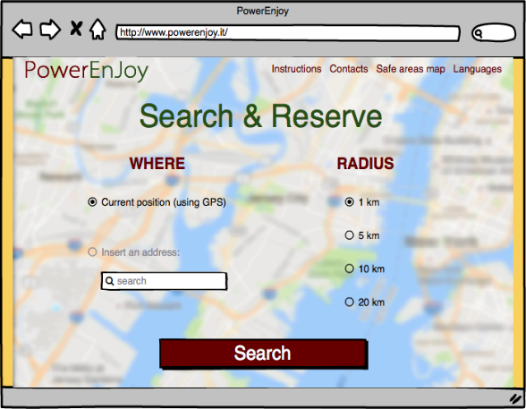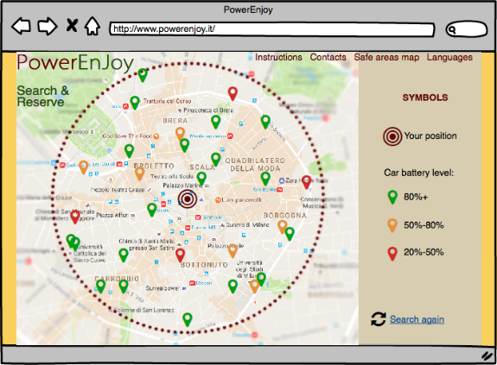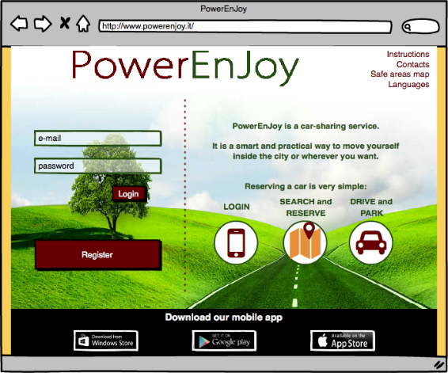

### 4.4.3. Unlock a car and end rental

Here it is described the sequence of actions concerning the phase of unlocking the car and end the rental with the application.

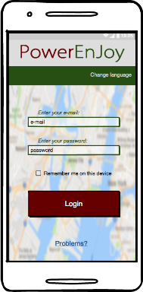

First of all, the user needs to be logged inside the system

The user, when he is nearby, can unlock the car

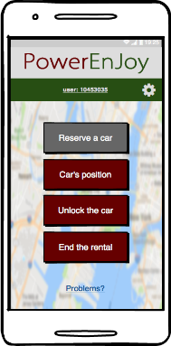

If the user tries to unlock the car when he is far more than 20 meters from the car, an error message will appear

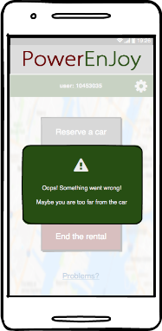

The user, whenever he wants, is able to end the rental

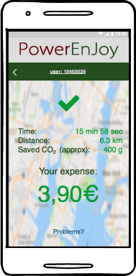

A recap contains all the information

# 5. Entities Architecture

## 5.1. E-R Diagram

In order to clarify the data structures used in the application, here is reported the ER (Entity-Relationship) diagram for the application database.

Every entity has a primary key, a field already suitable or inserted that is fundamental to identify every record of the database; in this way there are no weak entities.

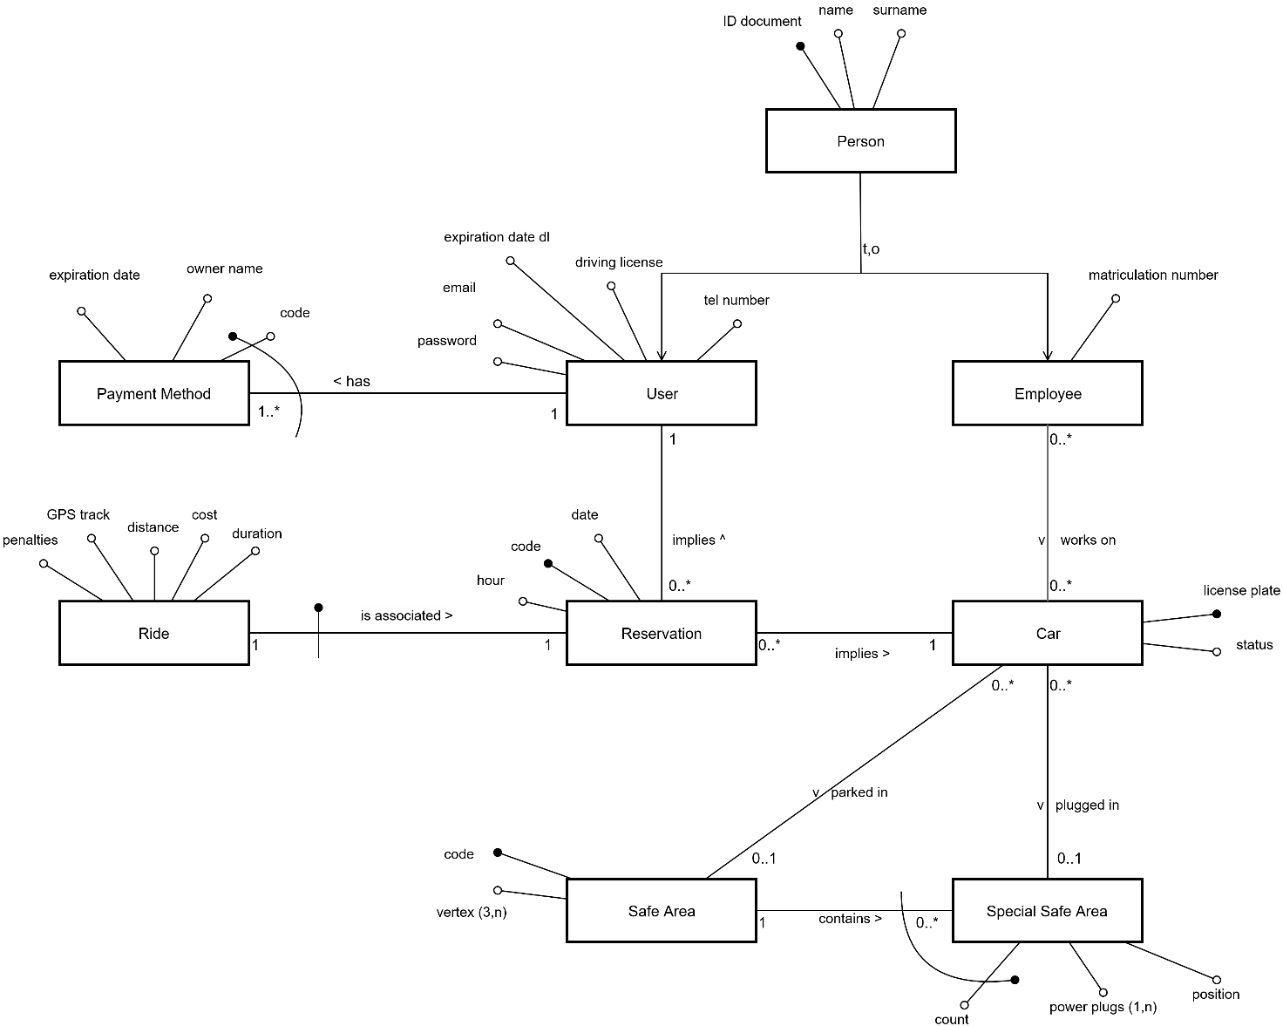Every relation between entities is represented with its cardinality, and the diagram uses the UML standard for entities and attributes, becoming clear to read and self-explaining.

## 5.2. Relational Model

From the ER diagram we can easily find out the Relational model:

* User(IDDocument, Name, Surname, Email, Password, DrivingLicense, ExpirationDate, TelNumber)
* Employee(IDDocument, Name, Surname, MatrNumber)
* PaymentMethod(CardCode, *UserID*, OwnerName, ExpirationDate)
* Reservation(ResCode, *UserID*, *Car*, Date, Hour)
* Ride(*ResCode*, Duration, Cost, Distance, GPSTrack, Penalties)
* Car(LicensePlate, Status)
* SafeArea(Code, Vertex)
* SpecialSafeArea(*SafeArea*, Count, PowerPlugs, Position)
* Work(*Employee*, *Car*)
* Parking(*Car*, *SafeArea*)
* Plugging(*SafeArea*, *Count*, *Car*)

Foreign keys are all the attributes in *italic*, and primary keys are the underlined.

Every entity has a primary key (that can be a couple too) that identifies uniquely every other attribute, and every relation is identified by the foreign keys belonging to the entities involved. The 1to1 and the 1toN relation has been absorbed by other entities. We wanted to keep both Ride and Reservation, for a more ordered model.

# 6. Requirements Traceability

G1

[R1] [R2]: The integrity of the Database allows to guarantee the uniqueness of usernames.

[R3] [R4] [R8]: Specific pages of the web application and the mobile apps permit to register and access to the platform

[R5] [R6]: The system is provided with a notification center that can communicate to users in case of necessity and manage all the e-mail involved in the communications

[R7]: The system exploit the services offered by the different credit cards producers in order to verify the validity of a credit card.

G2

[R1] [R3]: the Car Management component can ask to car their position; in addition, each car can retrieve its position and send it as an answer using the … module present on the car.

[R2]: Cars are provided with sensors managed by the main component management of the car that can answer to requests by the Car Management of the system.

[R4]: a page of the web (Available Cars) application allows user to search for cars; the request is managed by the Reservation Management of the system.

[R5]: The Database contains all the information in regard to safe areas that is managed by the Maps Management.

G3

[R1]: a specific page (Reservation) grant the possibility to select one car among the ones available.

[R2]: The Database contains all the information about past and actual rentals that are accessible through the interface offered by the Persistent Module

[R3] [R4]: The Reservation Management verify that users cannot rent another car while performing a rental. Moreover, only available cars can be rented.

[R5]: The Reservation Management check that the user that is completing a reservation has already paid the last monthly invoice.

G4

[R1]: The car module present on each car provide an interface that allows the Car Management to lock and unlock a car.

[R2]: The user sends his position together with the request to unlock the car and the system is able to retrieve the position of each car. At this point the Ride Management is able to calculate the distance between the two devices and verify if it is below 20m

[R3]: The LTE modem connection present on each car allows the connection to the different web servers. The mobile application can access to the system thanks its interfaces and perform different requests.

[R4]: Users take advantage of the GPS module present on their device in order to provide a correct position.

G5

[R1]: each car has an interactive display that is managed by the Car module present on each car.

[R2]: The Car Module can ask through the interface offered by the Car Management to begin the ride.

[R3]: The Car Module is able to calculate dynamically the amount of the fee

G6

[R1] [R2]: each car is provided with sensor that are used to retrieve information about the ride that are then sent to the Car Management.

[R3]: The Database contains the information about the fact that a car is currently plugged or not; in addition, it stores the special safe area where is plugged.

G7

[R1]: weight sensors placed under the seats reveals the number of passengers present on the car. If the number is 0, the Car Module sends this information to the Car Management.

[R2]: Map Management can check if a position is inside a safe area.

[R3] [R4]: the car Module can communicate with the system in order to confirm lock of it.

G8

[R1]: The Car Management Application (employee app) can take advantage of the interface offered by the Car Management in order to update the status of a car.

[R2]: the mobile application contains the number to call in order to contact the telephone exchange of the system in case of problem.

[R3]: cars and the system can communicate over the Internet through the provided interfaces.

[R4]: Car Management Application can check the position of the cars and notify employee if a car needs to be moved.

G9

[R1]: a specific page (Change Personal Information) allows users to update their personal information on the Database.

[R2]: The system can use services offered by the different credit cards to check the validity of a credit card.